Task 1:
import random

class SecuritySystem:

def __init__(self):
self.components = {}
for i in range(65, 74):
comp = chr(i)
self.components[comp] = random.choice([True, False])

def display_system(self):
print("\nSystem Status:")
print("-" * 30)
for comp, status in self.components.items():
state = "Safe" if status else "Vulnerable"
print(f"Component {comp}: {state}")
print("-" * 30)

class SecurityAgent:

def __init__(self):
self.vulnerable_list = []

def scan_system(self, system):
print("\nScanning System...")
print("-" * 30)
for comp, status in system.components.items():
if not status:
print(f"[WARNING] Component {comp} is Vulnerable!")
self.vulnerable_list.append(comp)
else:
print(f"[SUCCESS] Component {comp} is Secure.")
print("-" * 30)

def patch_vulnerabilities(self, system):
print("\nPatching Vulnerabilities...")
print("-" * 30)
for comp in self.vulnerable_list:
system.components[comp] = True
print(f"[PATCHED] Component {comp} has been secured.")
print("-" * 30)
self.vulnerable_list.clear()

system = SecuritySystem()
print("INITIAL SYSTEM CHECK")
system.display_system()

agent = SecurityAgent()
agent.scan_system(system)

agent.patch_vulnerabilities(system)

print("\nFINAL SYSTEM CHECK")
system.display_system()

Output:
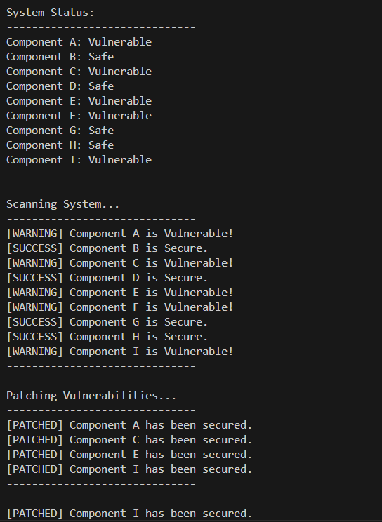
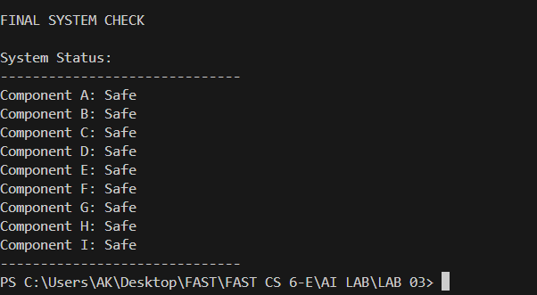

TASK 02:
import random
class DataCenter:
def __init__(self):
self.servers = {}
states = ["Underloaded", "Balanced", "Overloaded"]
for i in range(1, 6):
self.servers[f"Server{i}"] = random.choice(states)

def display_status(self):
print("\nServer Load Status:")
print("-" * 35)
for server, state in self.servers.items():
print(f"{server}: {state}")
print("-" * 35)

class LoadBalancer:
def scan_and_balance(self, datacenter):
overloaded = []
underloaded = []
for server, state in datacenter.servers.items():
if state == "Overloaded":
overloaded.append(server)
elif state == "Underloaded":
underloaded.append(server)

while overloaded and underloaded:
o_server = overloaded.pop()
u_server = underloaded.pop()

datacenter.servers[o_server] = "Balanced"
datacenter.servers[u_server] = "Balanced"

print(f"Moved tasks from {o_server} to {u_server}.")

datacenter = DataCenter()
print("INITIAL SYSTEM STATE")
datacenter.display_status()
agent = LoadBalancer()

print("\nBalancing Load...")
agent.scan_and_balance(datacenter)

print("\nFINAL SYSTEM STATE")
datacenter.display_status()

Output:
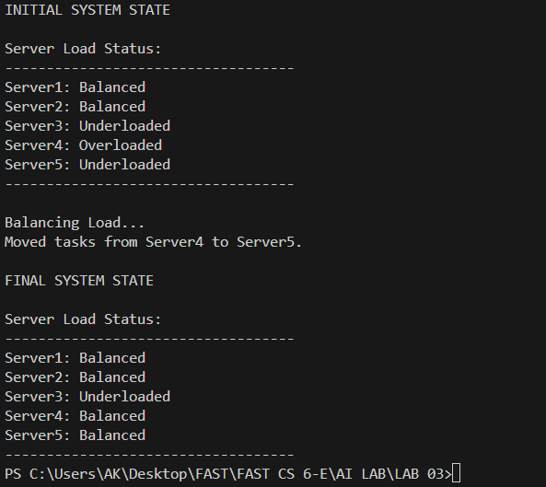
TASK 03
import random

class BackupSystem:
def __init__(self):
self.tasks = []
for i in range(1, 8):
status = random.choice(["Completed", "Failed"])
self.tasks.append({"Task": f"Backup{i}", "Status": status})

def display_tasks(self):
print("\nBackup Task Status:")
print("-" * 35)
for task in self.tasks:
print(f"{task['Task']}: {task['Status']}")
print("-" * 35)

class BackupManagementAgent:
def retry_failed_backups(self, system):
print("\nScanning for Failed Backups...")
print("-" * 35)
for task in system.tasks:
if task["Status"] == "Failed":
print(f"Retrying {task['Task']}...")
task["Status"] = "Completed"
print(f"{task['Task']} is now Completed.")
print("-" * 35)

system = BackupSystem()
print("INITIAL BACKUP STATUS")
system.display_tasks()

agent = BackupManagementAgent()
agent.retry_failed_backups(system)

print("\nFINAL BACKUP STATUS")
system.display_tasks()

Output:

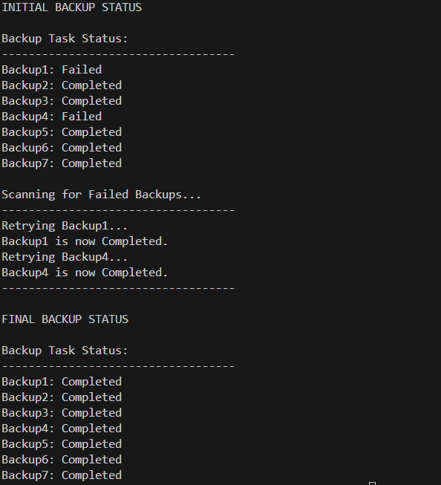
TASK 04:
import random

class SecuritySystem:
def __init__(self):
self.components = {}
states = ["Safe", "Low Risk Vulnerable", "High Risk Vulnerable"]
for i in range(65, 74):
self.components[chr(i)] = random.choice(states)

def display_system(self):
print("\nSystem Status:")
print("-" * 40)
for comp, state in self.components.items():
print(f"Component {comp}: {state}")
print("-" * 40)

class UtilityBasedSecurityAgent:
def __init__(self):
self.low_risk_list = []
self.high_risk_list = []

def scan_system(self, system):
print("\nScanning System...")
print("-" * 40)
for comp, state in system.components.items():
if state == "Safe":
print(f"[SUCCESS] Component {comp} is Safe.")
elif state == "Low Risk Vulnerable":
print(f"[WARNING] Component {comp} has Low Risk Vulnerability.")
self.low_risk_list.append(comp)
elif state == "High Risk Vulnerable":
print(f"[CRITICAL] Component {comp} has High Risk Vulnerability.")
self.high_risk_list.append(comp)
print("-" * 40)

def patch_vulnerabilities(self, system):
print("\nPatching Low Risk Vulnerabilities...")
print("-" * 40)
for comp in self.low_risk_list:
system.components[comp] = "Safe"
print(f"[PATCHED] Component {comp} Low Risk Vulnerability fixed.")

for comp in self.high_risk_list:
print(f"[ACTION REQUIRED] Component {comp} requires Premium Service for High Risk patch.")
print("-" * 40)
self.low_risk_list.clear()

system = SecuritySystem()

print("INITIAL SYSTEM CHECK")
system.display_system()

agent = UtilityBasedSecurityAgent()
agent.scan_system(system)

agent.patch_vulnerabilities(system)

print("\nFINAL SYSTEM CHECK")
system.display_system()

Output:
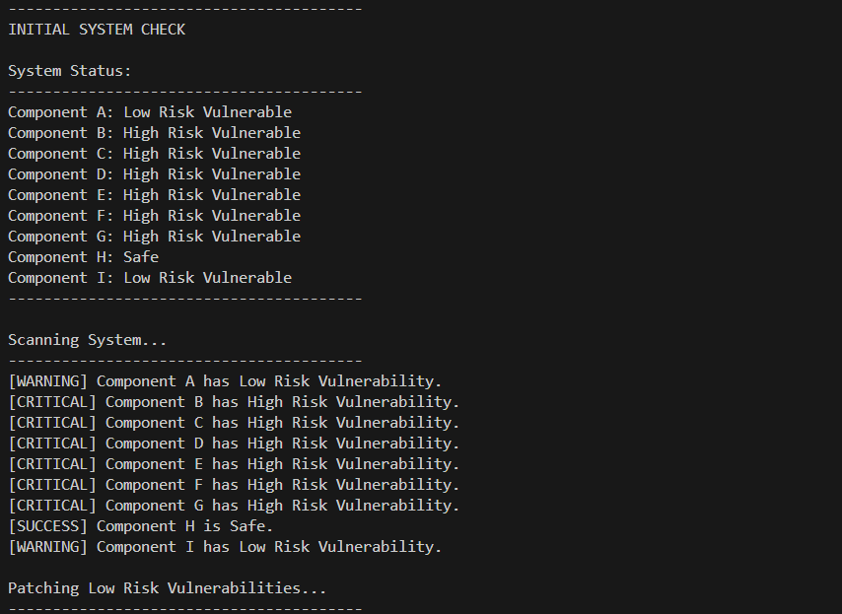

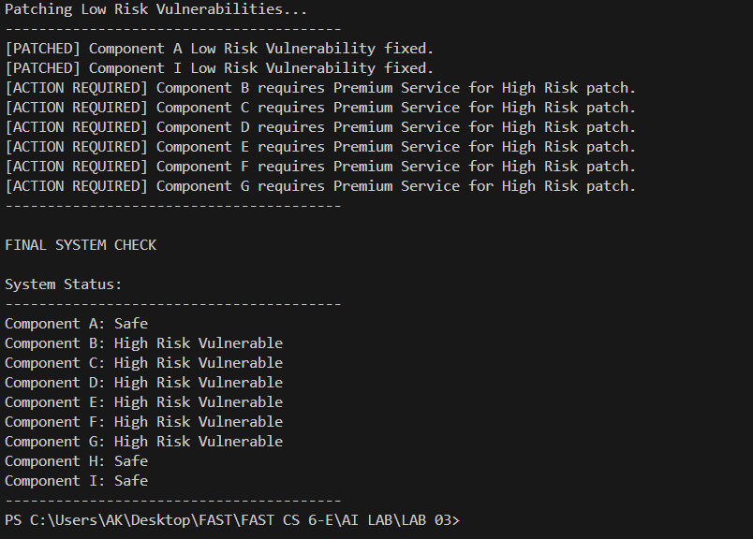

TASK 05:
import random
import time

class HospitalEnvironment:
def __init__(self):
self.corridors = ["Corridor1", "Corridor2"]
self.rooms = {
"Room101": {"patient_id": "P101", "medicine": "Paracetamol", "time": "10:00"},
"Room102": {"patient_id": "P102", "medicine": "Insulin", "time": "10:00"},
"Room103": {"patient_id": "P103", "medicine": "Antibiotic", "time": "10:00"}
}
self.nurse_station = "NurseStation"
self.medicine_storage = {
"Paracetamol": 5,
"Insulin": 5,
"Antibiotic": 5
}
self.staff_available = True

def display_schedule(self):
print("\nToday's Delivery Schedule")
print("-" * 40)
for room, data in self.rooms.items():
print(f"{room} -> Patient: {data['patient_id']} | Medicine: {data['medicine']} | Time:{data['time']}")
print("-" * 40)

class DeliveryRobot:
def __init__(self, environment):
self.env = environment
self.location = "DockingStation"
self.carrying = None

def move_to(self, location):
print(f"Moving from {self.location} to {location}")
self.location = location
time.sleep(0.5)

def pick_medicine(self, medicine):
if self.env.medicine_storage.get(medicine, 0) > 0:
self.env.medicine_storage[medicine] -= 1
self.carrying = medicine
print(f"Picked up {medicine}")
else:
print(f"{medicine} not available in storage")
self.alert_staff("Medicine shortage")

def scan_patient_id(self, expected_id):
print("Scanning patient ID...")
scanned_id = expected_id

if scanned_id == expected_id:
print("Patient ID verified")
return True

else:
print("Patient ID mismatch")
self.alert_staff("ID mismatch")
return False

def deliver_medicine(self, room):
if self.carrying is None:
print("No medicine to deliver")
return
expected_id = self.env.rooms[room]["patient_id"]
if self.scan_patient_id(expected_id):
print(f"Delivered {self.carrying} to {room}")
self.carrying = None

def alert_staff(self, reason):
if self.env.staff_available:
print(f"Alerting staff: {reason}")
else:
print("Staff not available, logging issue")

def execute_delivery(self):
for room, data in self.env.rooms.items():
self.move_to(self.env.medicine_storage)
self.move_to("MedicineStorage")
self.pick_medicine(data["medicine"])
self.move_to(room)
self.deliver_medicine(room)
print("-" * 40)

hospital = HospitalEnvironment()

robot = DeliveryRobot(hospital)

hospital.display_schedule()
robot.execute_delivery()

print("\nAll scheduled deliveries attempted.")

Output:
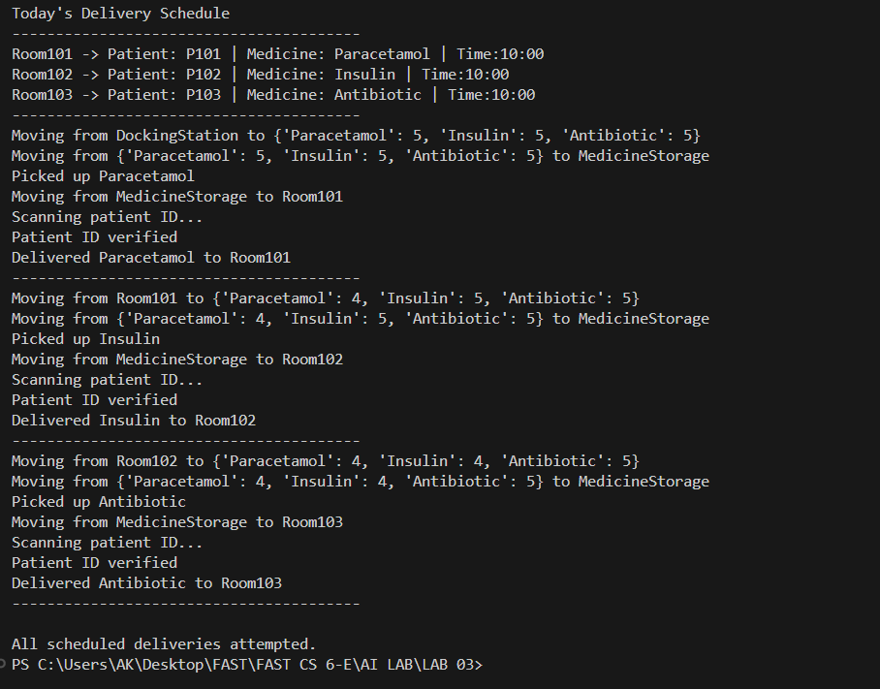

TASK 06:

